E-COMMERCE RETURN RATE REDUCTION ANALYSIS
Data Analytics and Machine Learning Project Report
Tools Used: Python, SQL, Power BI, Machine Learning
Dataset: E-commerce Returns Management Dataset
Total Records: 5,000
Project Duration: 7 Days

1. ABSTRACT
E-commerce product returns can affect business profitability, customer satisfaction, operational efficiency, and sustainability. This project, titled “E-commerce Return Rate Reduction Analysis,” focuses on analyzing customer return patterns and identifying factors associated with product returns.
The project uses an e-commerce returns dataset containing 5,000 order records. Python was used for data cleaning, exploratory data analysis, and machine learning. SQL-based analysis was performed to examine return patterns across product categories, shipping methods, payment methods, locations, discounts, and return reasons. A Logistic Regression model was developed to estimate the probability that an order would be returned.
The predicted return probabilities were categorized into Low, Medium, and High risk levels. Finally, an interactive Power BI dashboard was developed to visualize return rates, return reasons, risk distribution, customer and order patterns, and other important business indicators.
The overall analysis provides a data-driven approach for understanding product returns and supporting strategies to reduce avoidable returns.

2. INTRODUCTION
The rapid growth of e-commerce has increased the importance of effective return management. Product returns may occur because of size issues, defective products, incorrect items, or changes in customer decisions. A high return rate can increase return-processing costs and negatively affect business profitability.
Data analytics and machine learning can help organizations understand return behavior and identify orders that may have a higher probability of being returned.
This project analyzes historical e-commerce order and return data using Python, SQL, Power BI, and Logistic Regression. The project combines descriptive analytics with predictive modeling to provide a complete view of return behavior.

3. PROBLEM STATEMENT
E-commerce businesses need to understand why customers return products and which order characteristics are associated with higher return rates. Without proper analysis, it can be difficult to identify important return patterns or prioritize potentially high-risk orders.
Therefore, this project aims to analyze historical return data and develop a predictive model that estimates the probability of an order being returned.

4. OBJECTIVES
The main objectives of the project are:
- Analyze the overall e-commerce return rate.
- Identify the major reasons for product returns.
- Compare return rates across product categories.
- Analyze return patterns by shipping and payment methods.
- Examine geographical variations in return rates.
- Study the relationship between discounts and returns.
- Analyze the financial impact of returned orders.
- Build a Logistic Regression model for return prediction.
- Assign Low, Medium, and High return-risk levels.
- Develop an interactive Power BI dashboard.
- Provide data-driven recommendations for reducing returns.

5. DATASET DESCRIPTION
The dataset contains 5,000 e-commerce order records and 23 original attributes.
Important attributes include:
- Order ID
- Product ID
- User ID
- Order Date
- Product Category
- Product Price
- Order Quantity
- Discount Applied
- Shipping Method
- Payment Method
- User Age
- User Gender
- User Location
- Return Status
- Return Reason
- Days to Return
- Order Value
- Return Cost
- Profit/Loss
- CO2 Emissions
- Packaging Waste
- CO2 Saved
- Waste Avoided
The dataset contains five major product categories:
- Clothing
- Toys
- Books
- Home Appliances
- Electronics
The return reasons include Size Issue, Changed Mind, Wrong Item, and Defective.

6. DATA CLEANING AND PREPROCESSING
The dataset was inspected using Python before analysis.
The following checks were performed:
- Missing-value analysis
- Duplicate-record analysis
- Data-type verification
- Date conversion
- Categorical-value inspection
- Numerical-range inspection
The dataset contained no missing values and no duplicate records.
The Order_Date column was converted into a date format for time-based analysis.
A binary target variable called Return_Flag was created:
- 1 = Returned
- 0 = Not Returned
Additional time-related columns such as Year, Month, and Month Name were created for trend analysis.

7. EXPLORATORY DATA ANALYSIS
The dataset contains:
- Total Orders: 5,000
- Returned Orders: 1,450
- Not Returned Orders: 3,550
- Overall Return Rate: 29.0%
The major return reasons among returned orders were:
- Changed Mind
- Defective
- Size Issue
- Wrong Item
Return behavior was further analyzed according to product category, shipping method, payment method, user location, discount, and time.
The analysis also examined average order value, return cost, and profit/loss associated with different return conditions.

8. SQL ANALYSIS
SQL-style analytical queries were used to examine important business questions.
The analysis included:
- Overall return status and return rate.
- Return rate by product category.
- Return rate by shipping method.
- Return rate by payment method.
- Return reasons.
- Return rate by user location.
- Return rate by discount.
- Average order value by return status.
- Average return cost for returned orders.
- Average profit/loss by return reason.
These analyses helped identify patterns that could be used for business decision-making.

9. MACHINE LEARNING METHODOLOGY
A Logistic Regression model was selected to predict whether an order would be returned.
The following pre-return features were used:
- Product Category
- Product Price
- Order Quantity
- Discount Applied
- Shipping Method
- Payment Method
- User Age
- User Gender
- User Location
Categorical variables were converted into numerical features using one-hot encoding.
The dataset was divided into:
- 80% training data
- 20% testing data
Stratified train-test splitting was used to maintain the class distribution between the training and testing datasets.

10. MODEL EVALUATION
The Logistic Regression model was evaluated using:
- Accuracy
- Precision
- Recall
- F1-score
- Confusion Matrix
- ROC-AUC
The actual evaluation values obtained from the model were recorded in the accompanying model-evaluation screenshot.
Model Evaluation Screenshot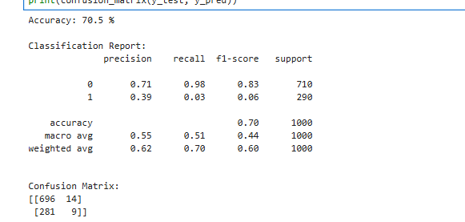
ROC-AUC Screenshot:
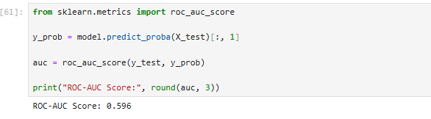
11. RETURN RISK PREDICTION
After training the model, return probability was calculated for all orders in the dataset.
Each order was assigned a risk category based on its predicted return probability:
- Low Risk: below 30%
- Medium Risk: 30%–60%
- High Risk: above 60%
The prediction dataset contains:
- Order ID
- Return Probability
- Risk Level
The generated prediction file was saved as:
return_risk_predictions.csv
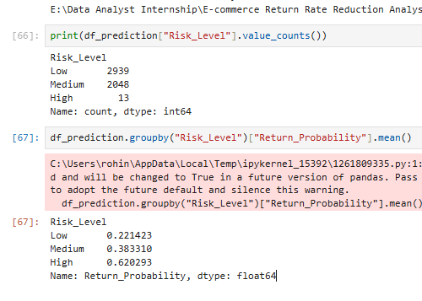
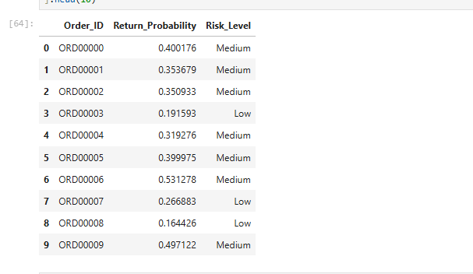
Return Risk Prediction Screenshot:

12. POWER BI DASHBOARD
An interactive Power BI dashboard was developed to present the analysis in a business-friendly format.
The dashboard contains the following KPI cards:
- Total Orders
- Returned Orders
- Return Rate
- Average Return Probability
- High Risk Orders
The dashboard visualizations include:
- Return Rate by Product Category
- Return Reasons
- Return Rate by Shipping Method
- Return Rate by Payment Method
- Monthly Return Trend
- Risk Distribution
- Location Analysis
Interactive slicers were added for:
- Product Category
- Shipping Method
- Payment Method
- Risk Level
- User Gender
These slicers allow users to dynamically explore different segments of the dataset.
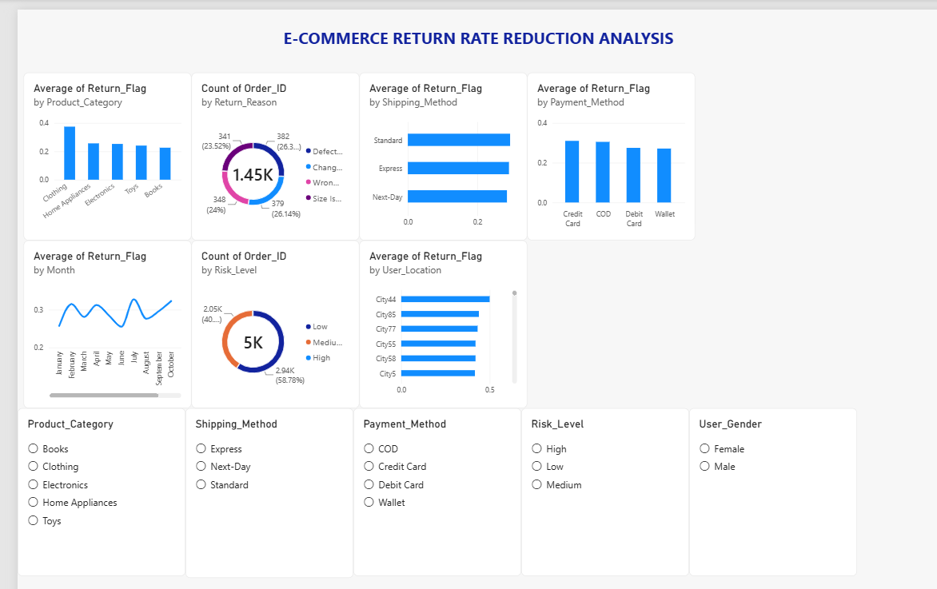
Dashboard Screenshot:
13. KEY FINDINGS
The analysis identified several important patterns:
- The dataset contains 5,000 orders.
- 1,450 orders were returned.
- The overall return rate was 29.0%.
- Multiple return reasons contributed to the overall return volume.
- Return behavior varies across product categories and order characteristics.
- Shipping and payment methods can be compared using return-rate analysis.
- Geographical differences can be explored using location-level return rates.
- The Logistic Regression model provides a probability-based approach to identifying potentially higher-risk orders.
- The Power BI dashboard allows business users to interactively explore these patterns.

14. BUSINESS RECOMMENDATIONS
Based on the analysis, the following actions can be considered:
Improve Product Information
Detailed product descriptions, accurate specifications, size information, and product images can help reduce avoidable returns.
Reduce Size-Related Returns
For categories where size issues are significant, businesses can improve size guides and provide better product-fit information.
Improve Quality Control
Products associated with defective-item returns can be investigated to identify quality-control problems.
Review Incorrect-Item Fulfillment
Warehouse picking and packaging processes can be reviewed when wrong-item returns occur frequently.
Monitor High-Risk Orders
The predictive model can be used to identify orders with higher predicted return probabilities and support proactive business actions.
Monitor Return Costs
Businesses can track return costs and profit/loss to understand the financial impact of returns.

15. TOOLS AND TECHNOLOGIES
Technology | Purpose
Python | Data cleaning and analysis
Pandas | Data manipulation
Matplotlib | Data visualization
Scikit-learn | Machine learning
Joblib | Model saving
SQL | Business data analysis
Power BI | Interactive dashboard
Jupyter Notebook | Development and analysis
16. PROJECT OUTPUTS
The main project outputs are:
- Cleaned dataset
- Exploratory data analysis
- SQL analysis queries
- Logistic Regression model
- Model evaluation
- Return probability predictions
- Risk-level classification
- Power BI dashboard
- Final project documentation

17. CONCLUSION
The E-commerce Return Rate Reduction Analysis project demonstrates how data analytics and machine learning can be combined to understand and predict product returns.
Python was used for data preparation, exploratory analysis, and predictive modeling. SQL-based analysis was used to investigate return patterns, while Power BI was used to create an interactive dashboard. Logistic Regression was applied to estimate the probability of returns using information available before the return event.
The resulting return-risk predictions can help businesses identify potentially higher-risk orders and investigate the factors contributing to returns. Overall, the project demonstrates an end-to-end data analytics workflow from raw data preparation to business visualization and predictive analysis.

18. FUTURE SCOPE
Future improvements could include:
- Testing advanced machine-learning algorithms such as Random Forest, XGBoost, or Gradient Boosting.
- Adding customer purchase-history features.
- Incorporating product-level historical return rates.
- Developing real-time return-risk prediction.
- Adding automated alerts for high-risk orders.
- Integrating the prediction system with an e-commerce platform.
- Using explainable AI techniques to identify the factors behind individual predictions.
- Adding more detailed geographical and product-level analysis.

19. PROJECT FILE STRUCTURE
Ecommerce-Return-Rate-Reduction-Analysis
│
├── Dataset
│ ├── cleaned_returns.csv
│ └── return_risk_predictions.csv
│
├── Python
│ ├── E-commerce_Return_Analysis.ipynb
│ └── return_prediction_model.pkl
│
├── SQL
│ └── return_analysis.sql
│
├── Power BI
│ └── E-commerce_Return_Analysis.pbix
│
└── Documentation
├── Project_Report.docx
├── Dashboard_Screenshot.png
├── Model_Evaluation.png
├── ROC_AUC.png
└── Return_Risk_Prediction.png

20. AUTHOR
Ananya S.
Project: E-commerce Return Rate Reduction Analysis

